Castles

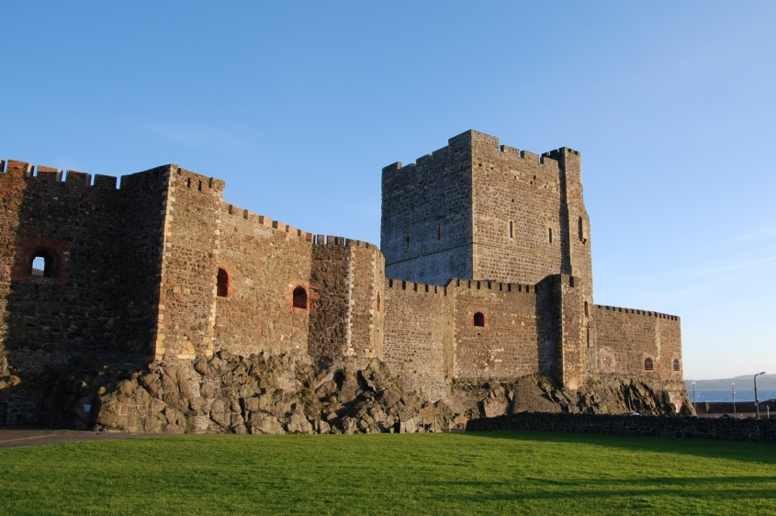
Why were castles built?
Castles were built for a two reasons. Firstly, they were constructed to defend those living within their walls. Secondly, they showed the power, strength and wealth of Lords.

What were castles made from?

The first castles were made from wood. Eventually, stone castles replaced the wooden castles. This is because stone is much stronger and doesn’t rot or burn.

Carrickfergus Castle

Did you know?

- Carrickfergus castle was built by the Normans over 800 years ago.
- The keep is over 20 metres high.
- 216 years ago, the castle was used as a prison.
Write the answers in your book in full sentences.

- Tell me one reason why castles were built.
- What were the first castles made from?
- What material replaced the wooden castles?
- How tall is the keep in Carrickfergus castle?
- What was the castle used as 216 years ago?

