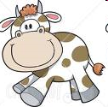
Three Loud Cows

Once upon there were three loud cows. One day they were staring at the clouds when the first loud cow said, “I am going to build a brown house out of straw.”
The loud cow was very proud of his brown, straw house.
After that, the second loud cow said, “I am going to build a brown house out of sticks.”
The loud cow was very proud of his brown, stick house.
Next the third loud cow said, “I am going to build a brown house out of bricks.”
The loud cow was very proud of his brown, brick house.

The next day a wolf found the first brown house, made of sticks. “Little cow, little cow, let me in!” he shouted.
“Not by the hairs on my chinny, chin, chin!” the loud cow shouted back.
So the wolf huffed and puffed and blew his house down. The loud cow found his brother’s brown house made of sticks and went to stay there.
“Little cows, little cows, let me in!” shouted the wolf.
“Not by the hairs on my chinny, chin, chin!” shouted the cows.
So the wolf huffed and puffed and blew the house down. The loud cows found their brother’s brown house made of bricks.

“Little cows, little cows, let me in!” shouted the wolf.
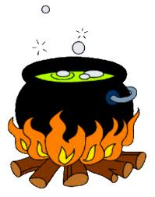
“Not by the hairs on my chinny, chin, chin!” shouted the cows.
The wolf huffed and puffed but he could not blow the house down. Instead, he climbed down the chimney, and landed in a bowl of boiling water!
“Ow!” shouted the wolf, and ran all the way home.
The cows cheered loudly, then lived happily ever after.

