Killer Whale
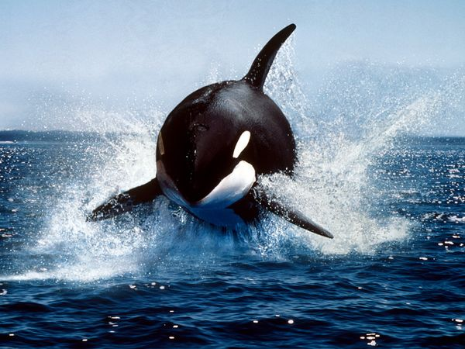

- Black and white
- Live between 30 and 50 years
- Have teeth
- Known as Orcas
- Travel in groups (pods)

Found in
Atlantic and Arctic Oceans

Eats Dolphins, fish, birds, seals and squid
Blue Whale

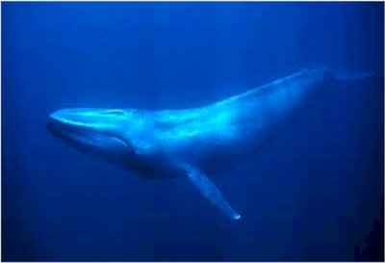

- Largest whale in the oceans
- Don’t have teeth
- Looks blue/grey under water
- Live between 80 and 90 years
- Larger than 23 elephants

Found in
Arctic, Atlantic, Pacific oceans

Eats
Krill and crabs
Humpback Whale
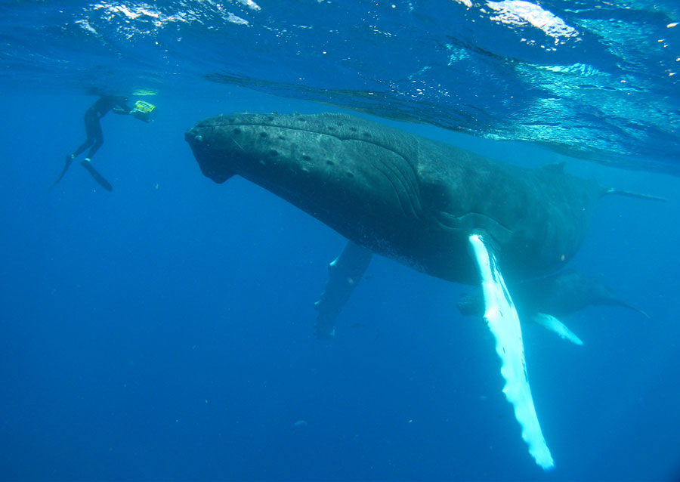

- Very large fins
- Have a hump on their back
- They like to sing songs
- Have no teeth
- Barnacles live on them
- Travel by themselves

Found
Iceland and Greenland
North Atlantic Ocean

Eats
Krill

Beluga Whales
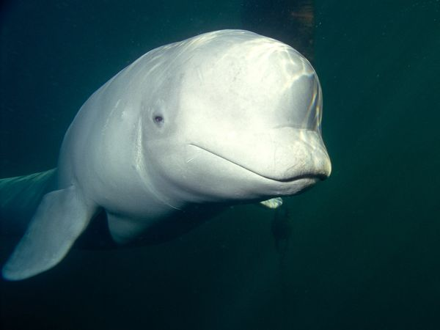

- Tiny eyes
- Round flippers
- White skin
- Melon-shaped head
- They are 5 metres long
- Have 34 teeth
- Dive between 3 and 15 minutes
- Live 25-30 years

Found in
The cold Arctic Ocean

Eats: Fish, squid, octopus

