The ‘ch’ sound
Chester the Chimp

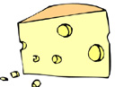
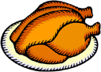
Chester was a chimp. On Fridays he went to the cafe at the zoo to have lunch. Chester could choose from chocolate, cheese, cherries, chicken, chips, chilli or chops. Today Chester decided to have chicken. When Chester was chewing his chicken, a cheeky cheetah walked in the cafe. Chester was afraid of cheetahs so he chucked the chicken up in the air and ran as fast as he could out the door.

Questions

- What day of the week did Chester go to the zoo?
- Why did Chester go to the zoo?
- What animal walked into the café when Chester was eating?
- What did Chester do when he saw the cheetah?
- What word in the story means the same as ‘eating’?

