‘igh’ Words

Use the words to fill in the spaces.
Add in capital letters and full stops.

- the stars come out at _____________
- when we got to the top of the mountain a wonderful _________ met our eyes
- will you switch the _____________ on please
- my shoes are hurting me, they are too _____________
- i ___________ be able to come over to your house this afternoon
- the British Airways ____________ to London was late this morning

Use these words to fill in the spaces
flight might sight night tight light

Off on Holiday

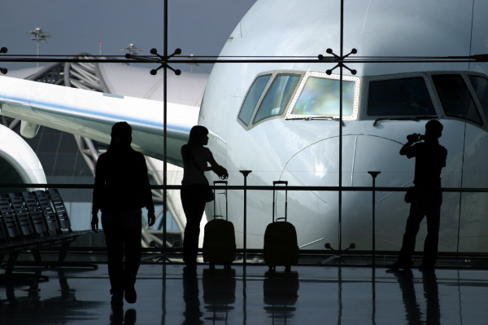
One night after tea, Dad and Jake went to the airport. They were going on a holiday to America. Their flight was due to take off at half past eight but they arrived early to check in. Once they arrived at the check-in desk they weighed their bags. “These bags are too heavy. You must make them lighter,” said the lady behind the desk. Dad sighed. “All right,’ he said as he turned towards Jake. “Let’s see what we can take out.” The suitcase was tightly packed. Luckily there was space for clothes in their hand luggage. A few minutes later, the bags were weighed again and placed on the conveyor belt to be put on the plane. Soon after, Dad and Jake walked past security and into the departure lounge to watch the planes landing. A few moments had passed when bright lights appeared from the darkness of the night sky. “Look,” said Dad. “That plane is going to land.”

Complete the sentences.
1. Dad and Jake went to the _______. They arrived early to__________________.
2. The bags were too _______ so Dad and Jake ____________________.
3. Dad and Jake went into the departure lounge to ________________________.
4. Where were Dad and Jake going on holiday?
- How did Dad feel when his bag was overweight?
- There wasn’t much space in the suitcase for more clothes. Which words in the story tell us that?
- What do you think happened next in the story?
- Write as many ‘igh’ words as you can from the story.

Off on Holiday

One night after tea, Dad and Jake went to the airport. They were going on a holiday to America. Their flight was due to take off at half past eight but they arrived early to check in. Once Dad and Jake arrived at the check-in desk they weighed their bags. “These bags are fine,” said the lady and she put them on the conveyor belt to be put the plane. Soon after, Dad and Jake walked past security and into the departure lounge to watch the planes landing. A few seconds had passed when bright lights appeared from the darkness of the night sky. “Look,” said Dad. “That plane is going to land.”

Complete the sentences.
1. Dad and Jake went to the _______.
2. They arrived _______ to check in.
3. Dad and Jake went into the departure lounge to ________________________.
4. Where were Dad and Jake going on holiday?
5. What time did Dad and Jake arrive at the airport?
- What do you think happened next in the story?
- Write as many ‘igh’ words as you can from the story.

