The Wind
The wind came out to play one day,
He swept the clouds out of his way.
He blew the leaves and away they flew,
The trees bent low and their branches did too.
The wind blew the great big ships at sea,
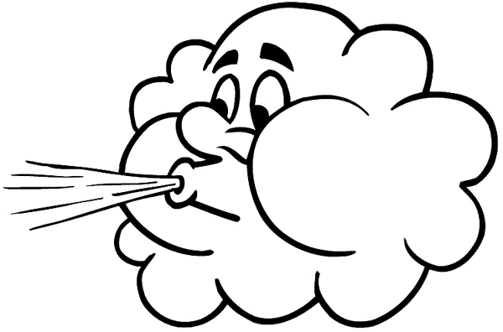
The wind blew my kite away from me.

The Wind
The wind came out to play one day,
He swept the clouds out of his way.
He blew the leaves and away they flew,
The trees bent low and their branches did too.
The wind blew the great big ships at sea,
The wind blew my kite away from me.
Something that I cannot see,
Makes a leaf dance in a tree.
Makes my hair fly in my face,
Blows the ball for me to chase.

The Wind
It pulls at your clothes
It tugs at your hair.
It whispers on windows
To make people stare.

It rattles your rooftop,
It creeps past each tree.
It charges down the chimney
And roars with the sea.

It climbs with each cloud,
It dives down below.
For the wind is with you
Wherever you go.

